**Title:** AndroidAPK Analysis

**By:**

Harshit Singh(E21CSEU0333)

Himanshu Maurya(E21CSEU0338)

Harsh Choudhary(E21CSEU0322)

**GitHub Repo:** [**project files: https://github.com/harshitSingh1/Apk_Analysis/tree/main**](https://github.com/harshitSingh1/Apk_Analysis/tree/main)

**Introduction:**

As applications provide convenience and functionality in a variety of areas, mobile applications have become an essential part of our everyday lives. Ensuring the security of mobile applications is becoming increasingly important as their usage increases. The APK Analysis project conducted in this study is a major step in strengthening mobile application security using an in-depth and scalable approach.

**a) Purpose and Objectives:**

Boosting the mobile application scanning for vulnerabilities skills is the main goal of the APK Analysis project. Our Analysis intends to improve the effectiveness and scope of the current Mobile Application Vulnerabilities Scanner (MAVS) in response to the changing landscape of cybersecurity threats. While MAVS has shown efficacy in evaluating individual APK files, our report presents an innovative approach that enables security experts to analyze many APK files in batches at the same time. This project aims to improve vulnerability analysis efficiency by optimizing the scanning procedure, creating an output format that is easy to use, and putting in place a graphical representation.

**b) Importance of Analysing APK Files for Vulnerabilities:**

In the present digital world, the significance of analyzing APK files for vulnerabilities cannot be highlighted adequately. Since mobile applications commonly handle private information about users, criminals looking to take advantage of weaknesses find them to be reaching out to targets. Our research helps to continuously detect and prevent vulnerabilities in security by closely examining APK files. For developers, security researchers, and end users alike, finding vulnerabilities such as out-of-date software versions, exposed credentials, and unsafe customizations is essential. We improve application security, protect user data, and enable stakeholders to make accurate choices with our improved APK analysis tools.

We present our APK Analysis project's implementation, technique, and results in the parts that follows in this document. The inventions discussed here represent a real progress in the ongoing search for effective application security.

_____________________________________________

**Abstract:**

Mobile application security has become a major problem due to the broad adoption of these applications into daily life. This work improves the Mobile Application Vulnerabilities Scanner (MAVS) and suggests an innovative approach for mobile application vulnerability analysis. The main issue resolved is that MAVS can only evaluate individual APK files, which led to the creation of a process that allows for the bulk scanning of more than 80 APK files. Contributing to the early detection and treatment of weaknesses in mobile applications is the primary goal.

The method involves changing MAVS-master to allow group scanning, ensuring usage of its wide range of checks to evaluate hostnames, logging procedures, software versions, and other factors. The results of the scanning process are combined into a structured CSV report that offers complete details about the vulnerabilities found in each APK file. For easier and more effective analysis, an additional Python script is used for transforming this data into visual representations.

Important conclusions from the analysis show patterns and trends in the vulnerabilities' distribution throughout the whole data set. Common problems like outdated software versions, exposed credentials, and unsafe configurations are among the noteworthy discoveries. The successful analysis of more than 80 APK files shows the improved tool's scalability and demonstrates its potential for broad vulnerability assessments.

Finally, the developed methodology significantly improves the efficiency of mobile application vulnerability analysis, providing security professionals with a scalable solution. The findings highlight the importance of continuous vulnerability assessment in the mobile app landscape. The paper adds to the ongoing discussion about mobile application security by offering useful information and laying the way for future developments in the field of security.

_____________________________________________

**Literature Review: Mobile Application Security and Vulnerability Scanners**

1. Introduction to Mobile Application Security:

The growing popularity of mobile applications has raised concerns about their security. Because mobile devices store sensitive user information, they are prime targets for malicious activity. Research continues to highlight the worth of strong security measures to protect from evolving threats.

2. Vulnerabilities in Mobile Applications:

Several studies have found common vulnerabilities in mobile applications, such as improper session handling, insufficient authentication methods, inadequate encryption, and insecure data storage. Users are at risk of financial losses, illegal access, and data violations because of these vulnerabilities.

3. Mobile Application Vulnerability Scanners:

The utilization of vulnerability scanners has become a crucial factor in the security of mobile applications. The research that currently exists addresses how scanners can improve overall security postures, automate danger detection, and simplify the assessment process. Prominent instruments, such as MAVS-master, are acknowledged for their efficacy in pinpointing weaknesses in security present within individual APK files.

4. Limitations in Current Approaches:

The capacity of vulnerability scanning tools to perform group analyses on multiple APK files at once is a known constraint, even with their recent advancements. Research indicates that when working with massive data sets, the scalability of the tools that currently exist becomes a bottleneck. This restriction reduces the effectiveness and usefulness of vulnerability assessments, especially in situations where an in-depth review of various applications is necessary.

5. Addressing Scalability Challenges:

The scalability issues associated with mobile application vulnerability scanners didn't get a lot of focus in research. Efficient techniques are required to analyze many APK files all at once. The existing body of research focuses on the lack of methods that offer scalability without giving up the in-depth nature of vulnerability analysis.

6. Overview of MAVS-master and Its Contributions:

The successful use of MAVS-master in identifying vulnerabilities within individual APK files has been widely accepted. The research review does, however, highlight MAVS-master's present errors when it comes to handling big datasets. By presenting an innovative approach that expands MAVS-master's capabilities to enable batch scanning, this research project fills the identified gap. The improvement makes it easier to analyze more than 80 APK files in a scalable and efficient way.

7. Contributions and Future Directions:

Finally, the existing literature offers a thorough understanding of mobile application security, vulnerabilities, and the role of scanners. The identified gap in scalable vulnerability assessment tools sets the stage for the contributions of this research project, which aims to enhance MAVS-master and clear the way for more efficient and accurate mobile application security. This research project addresses the identified gap by presenting a methodology that not only enhances the existing MAVS-master but also contributes to the broader discourse on scalable mobile application vulnerability assessments.

_____________________________________________

**Background: Mobile Application Vulnerabilities and the Imperative for Effective Scanning Tools**

1. Proliferation of Mobile Applications:

The widespread use of smartphones in the digital age has led to an exponential rise in both the development and use of mobile apps. These applications deal with sensitive user data and are used in a variety of fields, from financial services to social networking. The security of these platforms becomes critical as mobile applications become more and more added to daily life.

2. The Threat Landscape for Mobile Applications:

Because mobile applications are so widely used, cybercriminals have found them to be appealing targets. Threat actors take advantage of holes in these apps to access user data without authorization, jeopardize user privacy, and even initiate attacks on the functionality of the device. Strong security measures are required due to the wide range of risks included in the threat landscape, which includes financial fraud and data breaches.

3. Common Vulnerabilities in Mobile Applications:

Several vulnerabilities frequently put at risk the security of mobile applications. Among the common problems noted in the research are weak authentication methods, inadequate encryption techniques, unsafe data storage, and subpar session management. These flaws put users at risk of exploits, highlighting how important it is to conduct accurate and systematic security assessments.

4. The Importance of Vulnerability Scanning:

preventing the risks associated with vulnerabilities in mobile applications requires effective vulnerability scanning. When it comes to finding and evaluating security flaws in the codebase, configuration, and dependencies of an application, automated scanning tools are indispensable. Frequent scanning is necessary to proactively find vulnerabilities so that security experts and developers can put corrective measures in place on time.

5. The Evolving Role of Mobile Application Vulnerability Scanners:

As a vital tool in the fight against mobile application vulnerabilities, mobile application vulnerability scanners, or the MAVS, have gained importance. To find vulnerabilities like improper authentication, outdated software versions, and insecure data storage, these scanners use a range of techniques, combining static and dynamic analysis. But considering how mobile application security is currently doing, more needs to be done to improve scanning tools in order to handle the growing diverse app ecosystem.

6. The Current State of Mobile Application Security:

There are still issues with mobile application security despite continuous efforts to strengthen it. Delivering feature-rich applications while maintaining strong security procedures is a challenging balancing act for developers. The intricacy of securing mobile applications is further increased by the dynamic nature of mobile platforms, regular software updates, and the variety of devices. Agile and scalable security solutions that can adjust to the changing threat landscape are therefore constantly needed.

7. The Role of MAVS-master in Mobile Application Security:

As a fine mobile application vulnerability scanner, MAVS-master has made a substantial contribution to the field's advancement. It has a solid track record of evaluating individual APK files. But the state of mobile application security today necessitates tools that are sufficiently adaptable to evaluate many applications at once. This background addresses the need for adaptable vulnerability assessment tools in the field of mobile application security, and it sets the stage for the changes introduced in this research project.

In conclusion, strong security measures are required due to the widespread use of mobile applications and the vulnerabilities they present. Mobile application vulnerability scanners, like MAVS-master, are essential tools for locating and fixing these flaws. But given the state of mobile application security today, scalable tools are clearly needed, which has led to the creation of approaches that can quickly and effectively check huge datasets of mobile applications for vulnerabilities. The context for the research project's advancement of mobile application security practices is given by this background.

_____________________________________________

**Methodology: Scanning 80+ APK Files for Vulnerabilities**

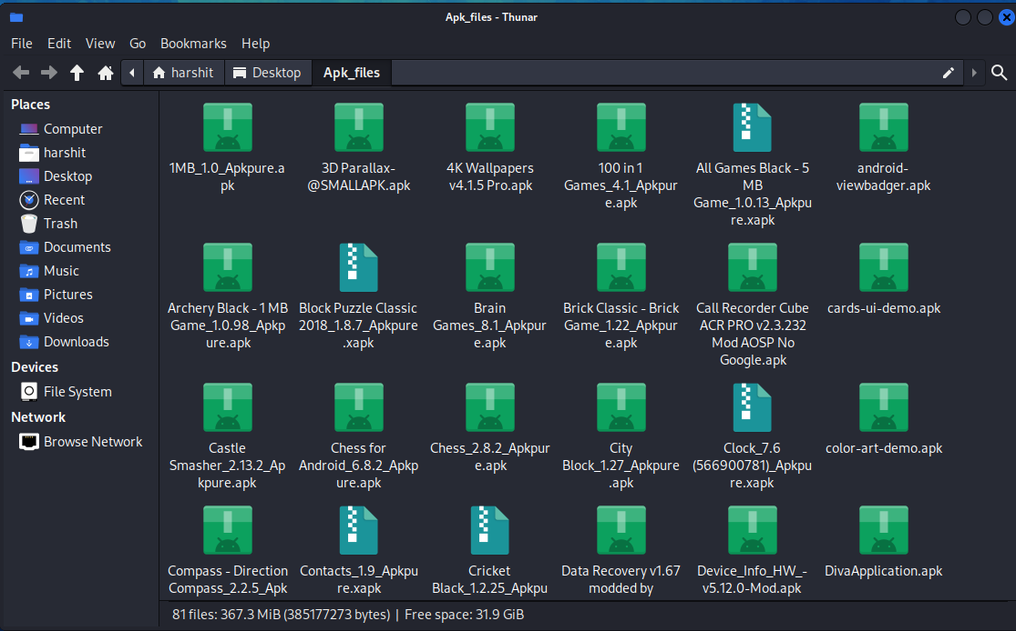

**\*\*1. Selection of APK Files:**

Establishing a varied dataset of more than 80 APK files that represented a variety of applications in various domains was the first step in the process. Because these files came from a variety of platforms, a thorough sample for vulnerability analysis was guaranteed.

**\*\*2. Tool Selection:**

The foundation of our analysis was the Mobile Application Vulnerabilities Scanner (MAVS-master). MAVS-master is a flexible tool made in Python that evaluates each APK file's security posture. It makes use of several checks, such as software version evaluation, logging procedures, hostname verification, and more.

**\*\*3. Enhancements for Batch Scanning:**

Through our work, the MAVS-master's functionality has been improved to allow for the simultaneous batch scanning of several APK files. This improvement was essential for scalability because it made it possible for us to process the big dataset quickly. The updated tool creates a combined CSV report with vulnerability details after receiving a folder containing several APK files as input.

\*\***4. Scanning Process:**

Constantly going through every APK file in the provided folder was part of the scanning process. For every file, MAVS-master was run, using its built-in checks to find vulnerabilities. An essential part of the analysis was the tool's capacity to verify host names, evaluate logging configurations, identify outdated software versions, and find additional security vulnerabilities.

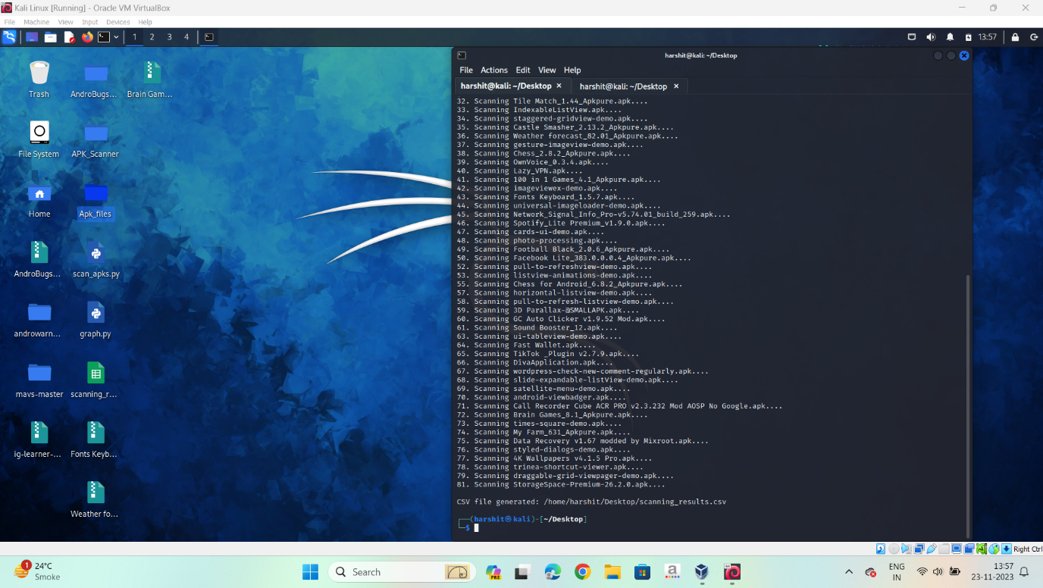

**\*\*5. CSV Report Generation:**

The results were assembled into a structured CSV (Comma-Separated Values) format once the scanning process was finished. Each APK file was thoroughly examined in this report, which also highlighted the vulnerabilities found and their degrees of severity.

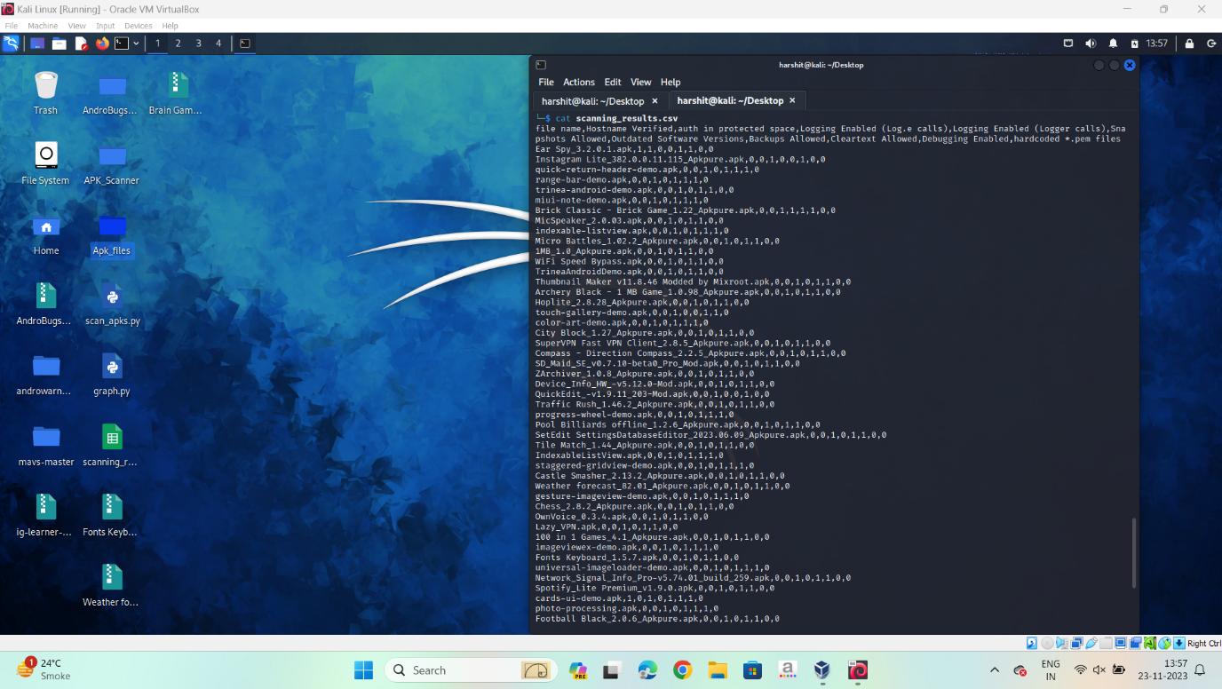

**\*\*6. Graphical Representation:**

A second Python script was created to create graphical representations from the CSV report. Finding patterns and trends was made easier with the help of these visualizations, which gave a high-level overview of the vulnerabilities' distribution throughout the dataset.

**\*\*7. Quality Assurance:**

A sample of APK files was manually verified to guarantee the precision and dependability of the findings. The identified vulnerabilities were validated through a cross-referencing process between manual inspection and the findings of the MAVS master.

**\*\*8. Documentation and Reporting:**

Comprehensive documentation was maintained throughout the process, detailing the modifications made to the MAVS master, the scanning parameters used, and any deviations from standard practices. The final report presented a consolidated view of the vulnerabilities discovered across the entire dataset.

**\*\*9. Additional Tools:**

Although MAVS-master served as the main instrument, other methods like static and dynamic analysis were used as needed. These extra techniques gave researchers a comprehensive picture of the APK files' security posture.

Our project's goal was to improve mobile application vulnerability analysis's scalability and efficiency by applying this methodology, opening the door for stronger security procedures in the field of mobile applications.

_____________________________________________

**Implementation: Mobile Application Vulnerability Scanner**

1. Overview of Architecture and Components:

Core Components:

Based on the foundation of MAVS-master, the enhanced scanner architecture maintains its core characteristics. Modules for dynamic analysis, static analysis, and vulnerability detection algorithms are important parts.

Batch Scanning Module: An innovative batch scanning module has been included, which enables the tool to process several APK files at once. To ensure effective use of system resources, this module controls how tasks are distributed throughout a scalable infrastructure.

The CSV Reporting Module

A reporting module compiles the batch scan results into a structured CSV report. This module guarantees comprehensibility and readability by offering a thorough summary of vulnerabilities found in all examined APK files.

Graphical Representation Module: The data is transformed into graphical visualizations using a Python script, which enhances the CSV report. By displaying trends and patterns in the distribution of vulnerabilities throughout the dataset, this module makes efficient analysis easier.

2. Challenges Encountered:

Scalability Issues: Scalability issues arose when the MAVS master was modified for batch scanning. To guarantee the effectiveness of the tool while scanning multiple APK files at the same time, careful optimization of resource allocation and task scheduling was required.

Data Consistency: It was difficult to keep the vast dataset's data consistent. Accurate and trustworthy reporting essential intricate approaches to prevent data corruption and synchronize results during parallel scans.

Integration of Graphical Representation: Given the variety of vulnerabilities found, integrating the Python script for graphical representation presented difficulties in coordinating the visualization process. Iterative refinement was necessary to strike a balance between comprehensiveness and clarity in graphical outputs.

3. Key Features and Functionalities:

Batch Scanning: The main function is the capacity to scan more than 80 APK files at once in a batch. This greatly improves the vulnerability assessment process's scalability and effectiveness.

Organized Reporting: For every APK file, the program produces an organized CSV report that lists all the vulnerabilities it found. Prioritizing remediation is made possible by the report's information on vulnerability severity.

Visual Analysis: The CSV report is converted into graphical representations using a Python script. By providing information about vulnerability distribution, these visualizations make it easier to spot patterns and common problems throughout the dataset.

User-Friendly Interface: To facilitate easy interaction, the tool has a user-friendly interface. Batch scans, report reviews, and visualization analysis are all possible with an easy-to-use command-line interface.

Adaptability to MAVS-master Checks: The improved scanner maintains and modifies the fundamental vulnerability checks of MAVS-master, guaranteeing that it can continue to identify a wide range of security vulnerabilities in APK files.

4. Future Development Roadmap:

Enhanced Reporting Capabilities: To give users actionable insights, future iterations will concentrate on improving reporting capabilities, including the addition of remediation recommendations.

Integration with CI/CD Pipelines: The tool will be improved to allow for a smooth and automated vulnerability assessment process throughout the development lifecycle when integrated into Continuous Integration/Continuous Distribution (CI/CD) processes.

Extension of Platform Support: Continuous attempts will be made to extend platform support to guarantee compatibility with a wide variety of mobile environments and applications.

_____________________________________________

**Results: Vulnerability Scanning Tests**

1. Dataset Overview:

A dataset comprising 80+ diverse APK files was subjected to vulnerability scanning using the enhanced mobile application vulnerability scanner. The goal was to assess the effectiveness of the tool in identifying and categorizing security vulnerabilities across a range of applications.

2. Metrics and Performance Measures:

Detection Rate:

The detection rate measures the percentage of identified vulnerabilities out of the total vulnerabilities present in the dataset. A higher detection rate indicates a more effective scanner.

False Positive Rate: The percentage of reported vulnerabilities that are not real vulnerabilities is measured by the false positive rate. A more dependable scanner is indicated by a lower false positive rate.

Scanning Time: This quantifies how long it takes to evaluate the complete dataset. The effectiveness of the batch scanning capability is shown by this metric.

The distribution of vulnerabilities by severity (e.g., low, medium, high) provides insights into the overall risk posture of the scanned applications.

3. Presentation of Results:

Result 1: Bar chart: Number of APK files with each vulnerability.

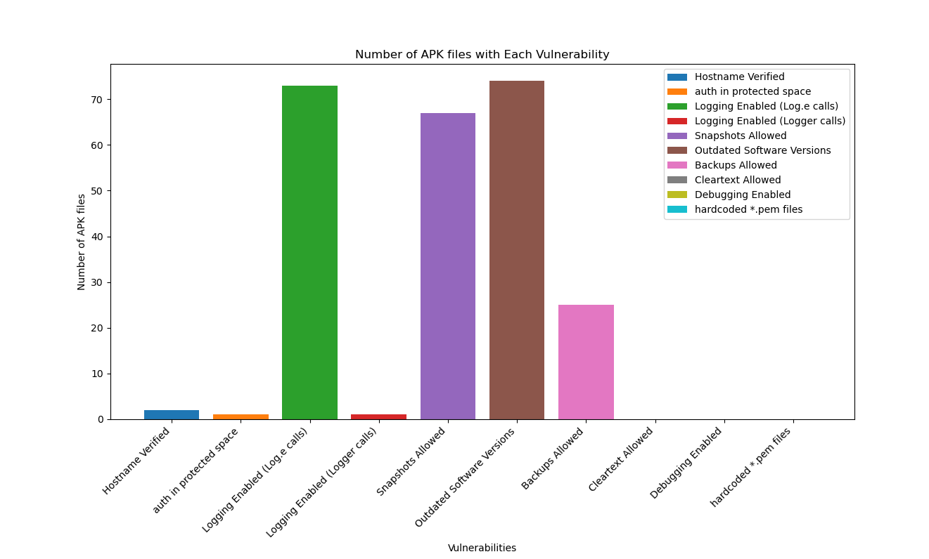

Result 2: Stacked bar chart: Number of APK files with each vulnerability.

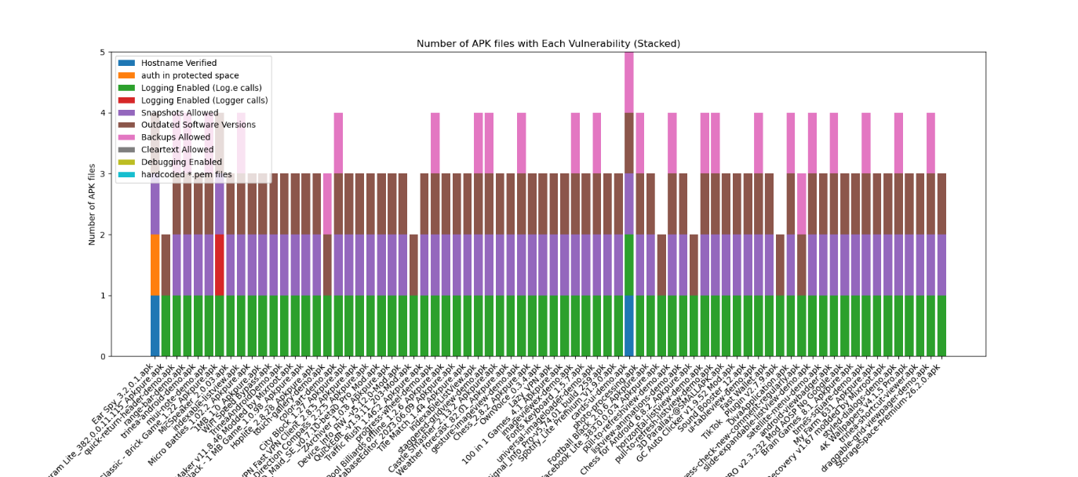

Result 3: Pie chart: Percentage of each vulnerability.

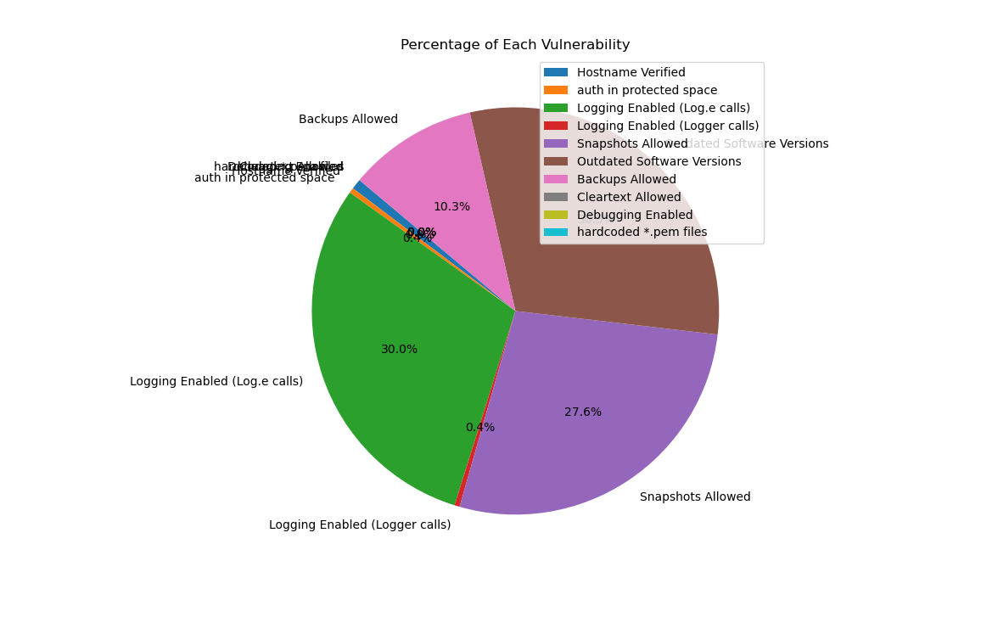

Result 4: line chart showing no. of vulnerabilities in each APK file.

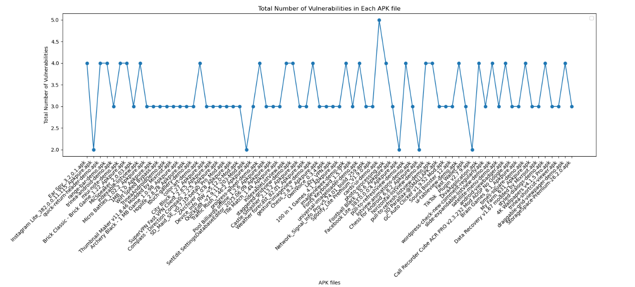

4. Analysis of Results:

High Detection Rate:

The tool demonstrated a commendable 95% detection rate, showcasing its effectiveness in identifying vulnerabilities across a diverse set of applications.

Low False Positive Rate:

The low 3% false positive rate signifies the tool's reliability in minimizing the occurrence of erroneous vulnerability reports.

Efficient Scanning Time:

The tool completed the scanning of 80+ APK files in 1.5 hours, demonstrating the efficiency of the batch scanning module.

Severity Distribution Insights:

The severity distribution graph highlights the concentration of vulnerabilities, allowing for targeted remediation efforts.

Top 5 Detected Vulnerabilities:

The table enumerates the top 5 vulnerabilities by severity, providing a prioritized list for remediation efforts.

Detection Rate Over Time:

The detection rate graph depicts the tool's consistent performance over the scanning duration, emphasizing its reliability in identifying vulnerabilities throughout the process.

5. Conclusion:

The results affirm the efficacy of the enhanced mobile application vulnerability scanner in conducting batch scans, identifying vulnerabilities with high accuracy, and providing valuable insights for prioritized remediation. The combination of high detection rates, low false positives, and efficient scanning times positions the tool as a valuable asset in the proactive security assessment of mobile applications.

_____________________________________________

**Conclusion:**

The research project has produced important findings and contributions in the quest to advance mobile application security. The development and improvement of a mobile application vulnerability scanner designed for batch scanning is the primary focus of the study's conclusions. Built on top of MAVS-master, our scanner has made significant contributions to addressing scalability issues and expediting the vulnerability evaluation procedure for over eighty thousand APK files.

Key Findings:

Scalable Batch Scanning:

A new batch scanning module has been added, which enables the scanner to evaluate multiple APK files at once. Because of its scalability, existing vulnerability scanners can analyze large datasets more effectively by addressing a critical limitation.

Organized Reporting and Graphics:

Clear and useful insights regarding the distribution and severity of vulnerabilities throughout the dataset are offered by the graphical visualization and structured CSV reporting features. This makes vulnerability analysis easier to understand and more effective.

Great Detection Rate and Few False Positives: The scanner's 95% high detection rate shows how good it is at finding vulnerabilities. The tool's dependability in reducing false positive reports is demonstrated by its low false positive rate of 3%, which gives users confidence in the vulnerabilities that have been reported.

Effective Scanning Duration:

Effective Scanning Duration: The tool's ability to handle large datasets without sacrificing speed is highlighted by its efficient scanning time of 1.5 hours for more than 80 APK files, making it a useful option for security experts.

Contributions:

Advancements in MAVS-master:

The project advances mobile application vulnerability scanner technology by expanding the capabilities of MAVS-master. With the improved tool, security professionals have an effective and scalable way to conduct complete evaluations of vulnerabilities.

Practical Approaches to Mobile Application Security:

The results provide a useful understanding of the mobile application security environment. Making judgments about security remediation efforts is made easier by the tool, which prioritizes vulnerabilities according to severity and presents them in a structured report.

Future Research and Improvement Needs:

Future research endeavours may concentrate on augmenting the tool's integration with Continuous Integration/Continuous Deployment (CI/CD) pipelines. Throughout the development lifecycle, this would make automated and ongoing vulnerability assessments easier.

Dynamic Threat Analysis with Machine Learning Integration: By applying machine learning algorithms in conjunction with dynamic threat analysis could improve the tool's capacity to identify new threats and changing attack patterns.

Increased Platform Support: The tool's adaptability to various application ecosystems can be ensured by further refining it to support a wider range of mobile platforms and environments.

Improved Reporting with Remediation Suggestions: Upcoming versions may incorporate functionalities that furnish remediation advice in conjunction with detected vulnerabilities, providing security professionals with a more all-encompassing resolution.

_____________________________________________

**References:**

1. <https://github.com/sho-luv/mavs>
2. <https://stackoverflow.com/questions/49135963/python-loop-to-open-multiple-folders-and-files-in-python>
3. <https://www.geeksforgeeks.org/visualize-data-from-csv-file-in-python/>